Chinese Link, L1 P2, L15 Location and Position (150pts)
Work in group of three, draw a simple house floor plan (see the example of house floor plan below), create a 12-sentence dialogue, type the dialogue, memorize the script and do oral presentation.
Rubric:
- Create a title for the dialogue.
- Create a 12-sentence dialogue using the format of L15 Language in Use on P73-74.
- Use Chinese names.
- In the floor plan you must include kitchen廚房, dining room餐廳, living room客廳, bedroom臥室, bathroom洗澡間 & garage車庫and write the following rooms in Chinese.
- Apply all of the following furniture (table/desk桌子/書桌, bed床, chair椅子, closet/wardrobe衣櫥) & window窗子/窗戶 in the dialogue.
- Apply some of the following position phrases:旁邊nearby or next to/右邊to the right/左邊to the left/中間in the middle of/外邊outside of/裡邊inside of/對面opposite or across/前邊in front of/後邊in the back/東邊to the east/西邊to the west/南邊to the south/北邊to the north/上面on top of/下面beneath or under.
- Each sentence must have 6 or more words.
- Each group only submits ONE house floor plan (hand draw).
- Each group can have ONE person type the script. However; each one of you needs to submit the typing script via GC in order to receive a typing credit.
- Memorize the script prior to the oral presentation.
- Each student needs to submit a copy of writing script prior to the oral presentation.
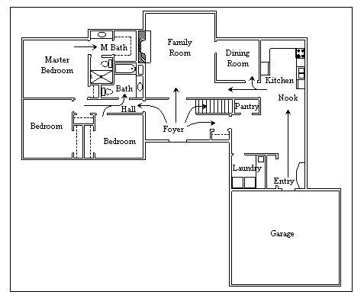
House Floor Plan 20pts
Writing Script 50pts
Typing Script 30pts
Oral Presentation 50pts

